1. When I launched the app through Appium with below capabiities passed:

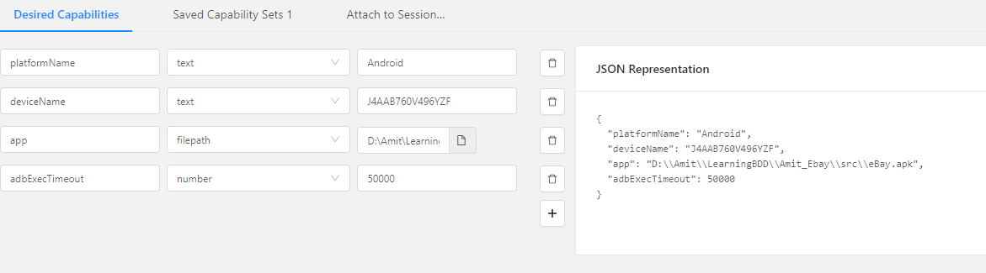

1. It is showing error on HomePage as per below Screenshot.

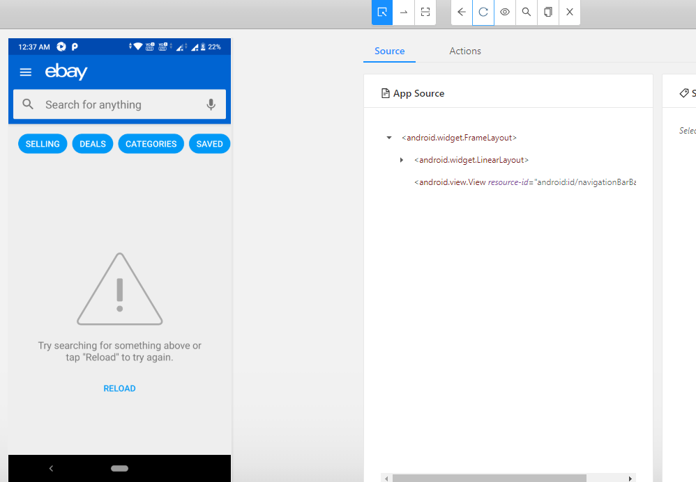

1. As mentioned in the Mail,
2. After Launching
3. I clicked on humburger Menu
4. Then clicked on setting tab
5. Then Navigated to Country/region and selects Australia as country

As per below Screenshot.

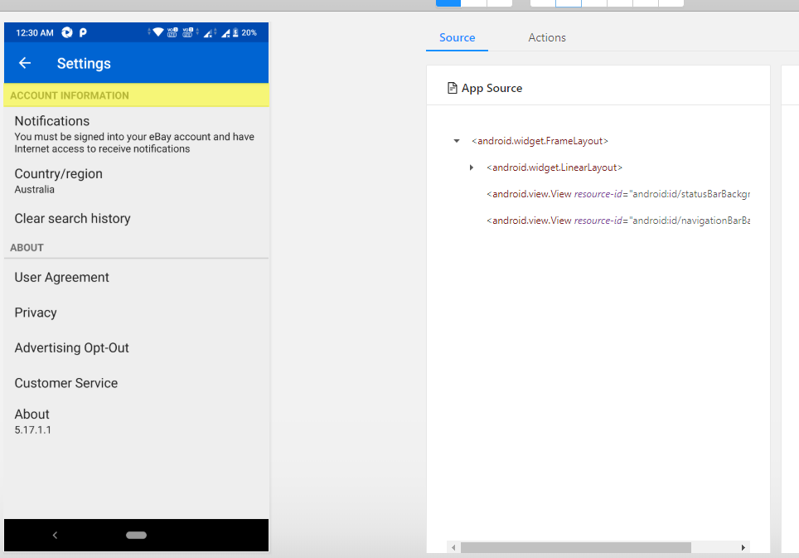

1. Then when I start Searching TV, I am getting Invalid Request as error message

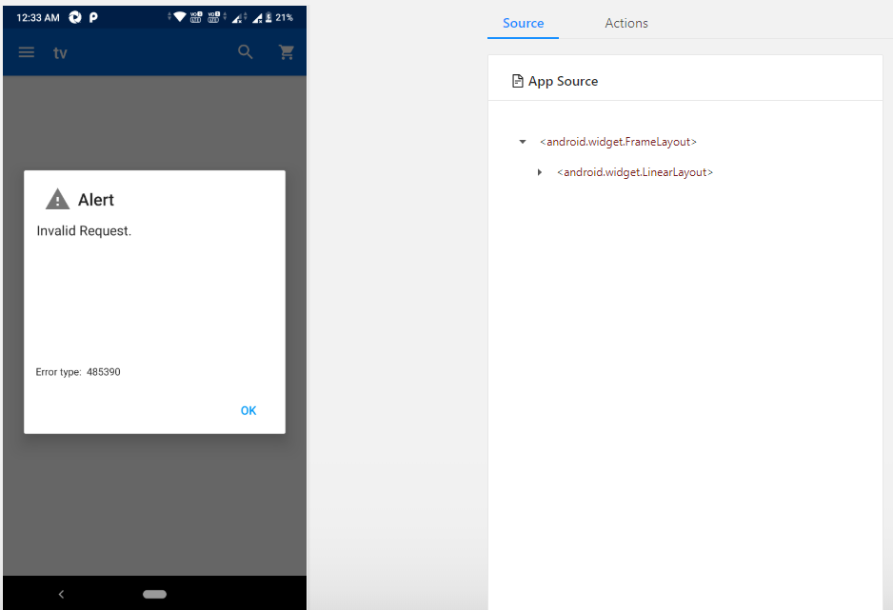

1. I tried to search with another way
2. Clicked on Categories Tab
3. Then I select Electronics categories
4. To see all Tv, Videos and accessories
5. But Again I got response as Invalid Request.

